C:\Users\Chaig\AppData\Local\Microsoft\Windows\Temporary Internet Files\Content.IE5\ZO9KRRFT\MC900089832[1].wmfBED BUG TREATMENT – *SPRAYING*

DAY OF TREATMENT

C:\Users\Chaig\AppData\Local\Microsoft\Windows\Temporary Internet Files\Content.IE5\ZO9KRRFT\MC900232964[1].wmfC:\Users\Chaig\AppData\Local\Microsoft\Windows\Temporary Internet Files\Content.IE5\4USGD6LR\MC900215620[1].wmf

**DOUBLE-CHECK that you have FINISHED your PREPARATIONS**

**C:\Users\Chaig\AppData\Local\Microsoft\Windows\Temporary Internet Files\Content.IE5\766DNN2G\MC900023537[1].wmf**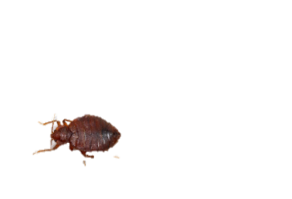C:\Users\Chaig\AppData\Local\Microsoft\Windows\Temporary Internet Files\Content.IE5\TZCYVM02\MC900078790[1].wmfC:\Users\Chaig\AppData\Local\Microsoft\Windows\Temporary Internet Files\Content.IE5\ZO9KRRFT\MC900013096[1].wmf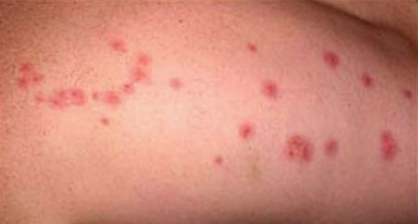C:\Users\Chaig\AppData\Local\Microsoft\Windows\Temporary Internet Files\Content.IE5\W9STMG3H\MC900078753[1].wmfC:\Users\Chaig\AppData\Local\Microsoft\Windows\Temporary Internet Files\Content.IE5\9JJFLMPB\MC900389390[1].wmf**C:\Users\Chaig\AppData\Local\Microsoft\Windows\Temporary Internet Files\Content.IE5\766DNN2G\MC900023537[1].wmf**C:\Users\Chaig\AppData\Local\Microsoft\Windows\Temporary Internet Files\Content.IE5\9JJFLMPB\MC900389390[1].wmfC:\Users\Chaig\AppData\Local\Microsoft\Windows\Temporary Internet Files\Content.IE5\W9STMG3H\MC900078753[1].wmfC:\Users\Chaig\AppData\Local\Microsoft\Windows\Temporary Internet Files\Content.IE5\ZO9KRRFT\MC900078735[1].wmf

AFTER TREATMENT

**THEY WILL SPRAY AGAIN IN 7 – 14 DAYS**



**10 DAYS**

**SPRAYING COSTS MONEY – IF YOU ARE NOT CAREFUL (if you don’t follow instructions!)**

**YOU CAN BE CHARGED FOR THE NEXT TREATMENT!**

**$**

**BE VERY VERY VERY CAREFUL ABOUT NOT LETTING BED BUGS BACK INTO YOUR HOME**

**WATCH FOR BUGS, BUG POOP OR BITES!**

**WHEN YOU RETURN to YOUR HOUSE you can RETURN your THINGS**

**BUT**

**ONLY WHAT YOU NEED**

**THE CHEMICAL that they will SPRAY is SAFE ONLY WHEN DRY – SO YOU MUST STAY AWAY FROM HOME WHILE IT IS DRYING**

**LEAVE your HOUSE and STAY AWAY for a MINIMUM OF 6 HOURS**

**TAKE ONLY the CLOTHES and THINGS**

**you NEED**

**USE these PAPERS we give YOU to HELP CHECK**