C:\Users\Chaig\AppData\Local\Microsoft\Windows\Temporary Internet Files\Content.IE5\ZO9KRRFT\MC900089832[1].wmfBED BUG TREATMENT – *SPRAYING*

1 DAY BEFORE TREATMENT!

C:\Users\Chaig\AppData\Local\Microsoft\Windows\Temporary Internet Files\Content.IE5\766DNN2G\MC900250797[1].wmfC:\Users\Chaig\AppData\Local\Microsoft\Windows\Temporary Internet Files\Content.IE5\ZO9KRRFT\MC900312546[1].wmf

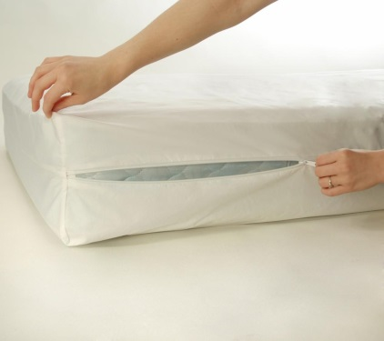C:\Users\Chaig\AppData\Local\Microsoft\Windows\Temporary Internet Files\Content.IE5\RLKZSUGV\MC900030276[1].wmfC:\Users\Chaig\AppData\Local\Microsoft\Windows\Temporary Internet Files\Content.IE5\RLKZSUGV\MC900356901[1].wmfC:\Users\Chaig\AppData\Local\Microsoft\Windows\Temporary Internet Files\Content.IE5\W9STMG3H\MC900078753[1].wmfC:\Program Files (x86)\Microsoft Office\MEDIA\CAGCAT10\j0234131.wmfC:\Users\Chaig\AppData\Local\Microsoft\Windows\Temporary Internet Files\Content.IE5\RLKZSUGV\MC900030328[1].wmf

**BUY BOX SPRING and MATTRESS COVERS for ALL BEDS**



**DO NOT MOVE THINGS TO NEW ROOM**

**OR NEW HOUSE**

**BED BUGS**

**CAN LIVE ANYWHERE**

**BUT A TIDY AND CLEAN HOUSE GIVES THEM FEWER PLACES TO HIDE!**



**MOVE FURNITURE**

1 foot away from walls



**PUT ALL BAGS in MIDDLE OF ROOM**

**VACUUM**

**and IMMEDIATELY EMPTY and put in GARBAGE OUTSIDE**

**REMOVE ALL ITEMS from TABLES and SHELVES and FLOOR**

**CLEAN with RUBBING ALCOHOL**

**LOOK VERY CLOSELY**

For bugs or bug poop

