C:\Users\Chaig\AppData\Local\Microsoft\Windows\Temporary Internet Files\Content.IE5\ZO9KRRFT\MC900089832[1].wmf

BED BUG TREATMENT – *SPRAYING*



1 DAY BEFORE TREATMENT!

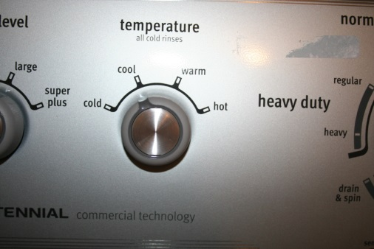C:\Users\Chaig\AppData\Local\Microsoft\Windows\Temporary Internet Files\Content.IE5\TOFORZ0X\MC900320182[1].wmfC:\Users\Chaig\AppData\Local\Microsoft\Windows\Temporary Internet Files\Content.IE5\4USGD6LR\MC900391100[1].wmfC:\Users\Chaig\AppData\Local\Microsoft\Windows\Temporary Internet Files\Content.IE5\TZCYVM02\MC900044904[1].wmfC:\Users\Chaig\AppData\Local\Microsoft\Windows\Temporary Internet Files\Content.IE5\766DNN2G\MC900435302[1].wmfC:\Users\Chaig\AppData\Local\Microsoft\Windows\Temporary Internet Files\Content.IE5\VS2BTW4I\MC900044907[1].wmfC:\Users\Chaig\AppData\Local\Microsoft\Windows\Temporary Internet Files\Content.IE5\766DNN2G\MC900435302[1].wmfC:\Users\Chaig\AppData\Local\Microsoft\Windows\Temporary Internet Files\Content.IE5\ZO9KRRFT\MC900113458[1].wmfC:\Users\Chaig\AppData\Local\Microsoft\Windows\Temporary Internet Files\Content.IE5\4USGD6LR\MC900215620[1].wmfC:\Users\Chaig\AppData\Local\Microsoft\Windows\Temporary Internet Files\Content.IE5\ZO9KRRFT\MC900013096[1].wmfC:\Users\Chaig\AppData\Local\Microsoft\Windows\Temporary Internet Files\Content.IE5\ZO9KRRFT\MC900232964[1].wmf

**SEPARATE 1 DAY OF CLOTHES FOR WHOLE FAMILY TO WEAR TOMORROW**

**(day of treatment)**

**SEALED IN BAGS**

(until treatment is finished!)

**WASH**

(hot!)

**DELICATE CLOTH**

(put in pillow case and put into dryer without washing)

**SEALED IN BAGS**

(TIE TIGHTLY!)

**DRY**

(1.5 hours HOT!)

**ALL CLOTHES**

(pants, shirts, pajamas, underwear, saris, scarfs, hats - **everything**!)