C:\Users\Chaig\AppData\Local\Microsoft\Windows\Temporary Internet Files\Content.IE5\ZO9KRRFT\MC900089832[1].wmf

BED BUG TREATMENT – *SPRAYING*

1 DAY BEFORE TREATMENT!

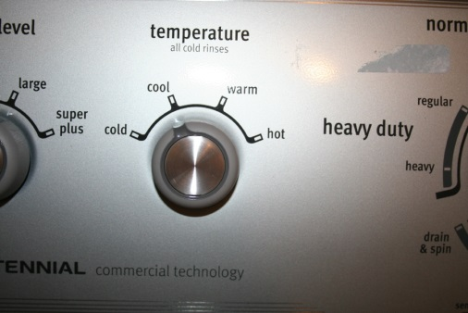C:\Users\Chaig\AppData\Local\Microsoft\Windows\Temporary Internet Files\Content.IE5\766DNN2G\MC900232855[1].wmfC:\Users\Chaig\AppData\Local\Microsoft\Windows\Temporary Internet Files\Content.IE5\4USGD6LR\MC900391100[1].wmfC:\Users\Chaig\AppData\Local\Microsoft\Windows\Temporary Internet Files\Content.IE5\TOFORZ0X\MC900320182[1].wmf

**WASH**

(hot!)

**SEALED IN BAGS**

(until treatment is finished!)

**DRY**

(1.5 hours HOT!)

**ALL BEDDING**

(pillows, sheets, blankets, mattress covers, bed skirts – everything!)

**SEALED IN BAGS**

(TIE TIGHTLY!)